ONLINE CONSTRUCTION MATERIALS MONITORING SYSTEM

AIM
Thus Materials management is an important element in project management. Materials represent a major expense in construction, so minimizing procurement costs improves opportunities for reducing the overall project costs.

ABSTRACT

Online building construction is a website portal where building constructors, suppliers and contractors can meet and chat. In this website, house owners/business owner /constructors who is constructing their buildings in particular area can register their details like area, work details, etc., The suppliers who supplies constructing materials can also register their details like product details, cost details, discount details, etc., The contractors can also register their details. This website helps the contractors to search for building construction area and can get the contract from owners. It helps the suppliers for their business so that they can contact the contractors for supplying the items. It helps the building owners to know about all constructors details. Any registered members can chat in this website. The admin can send notification to all registered contractors and suppliers through the mail. So, owner can easily find the best workers at a short time period. This website is very helpful to suppliers and contractors for their business and even building owners can choose a best contract tor for their construction.

PROJECT CATEGORY: WEB application
EXISTING SYSTEM

- The construction materials and technology covered include: cement, concrete reinforcement, bricks and mortars, additives, corrosion technology, ceramics, timber, steel, polymers, glass fibres, recycled materials, bamboo, rammed earth, non-conventional building materials, bituminous materials and railway material applications.
- At a time when the pressure is on all engineers, architects and contractors to optimise use of new materials and up-to-date technologies, Construction and Building Materials provides essential information that will help improve efficiency, productivity and competitiveness in world markets.

PROPOSED SYSTEM

The scope of Construction and Building Materials includes, but is not restricted to and monitoring aspects of new works and repair and maintenance of the following: bridges, high-rise buildings, dams, civil engineering structures, silos, highway pavements, tunnels, water containment structures, sewers, roofing, housing, coastal defences and railways.

SOFTWARE AND HARDWARE REQUIREMENTS

HARDWARE REQUIREMENTS

- Processor : Dual core processor2.6.0 GHZ
- RAM : 4 GB
- HARD DISK : 512 GB
- Compact Disk : 650 MB
- Keyboard : Standard Keyboard
- Monitor : 15-inch Color monitor

SOFTWARE REQUIREMENTS

- Operating system : Windows OS( 7, 8)
- Front End : HTML,CSS
- Back End : MYSQL, PHP

MODULES DESCRIPTION
Authentication Module:
This module is used for authentication purpose. It makes the project more secure from mistrusted parties.
Suppliers Module:
In this module supplier register their details used for customer easily contact with suppliers.
Constructors Module:
In this module constructor register their details. They register building constrains duration, works details and total amount for contract. Customer choose the contractor based on these details.
Customer Module:
In this Module customer register their details and choose the contractor for constrains building.
Chat Module:
In this Module help full for customer supplier and constructor communication one with another.

ER–DIAGRAM

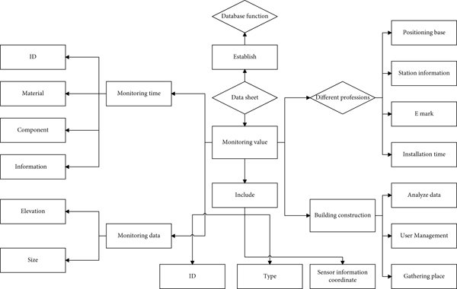

FUTURE SCOPE
In future, based on presented tracking-based method for solving the difficulties of site and intermediate inventory management and transparency can be considered a useful addition to the current body of literature. Its practical relevance is emphasized in project-oriented industries, as it is challenging and often infeasible to establish traditional inventory management systems to temporary storage locations used during projects.

Signature of the Guide Signature of the HoD

